Let Them Come Chroma DLL Developer Guide

Overview
This is a quick guide to using the LetThemComeChromaAPP tool. The tool is intended for developers who seek to quickly prototype Chroma effects by hooking a dll which implements specific effects directly into their application. The tool consists of 2 primary components:
- LetThemComeChromaDLL - this is the .dll that implements the events which trigger the rendering of a Chroma effects onto a Chroma device. A developer can then hook the dll into their game application and trigger the included events to quickly see the resulting Chroma lighting effect on connected Chroma devices
- LetThemComeChromaAPP - a sample .exe that provides an example of how to hook the LetThemComeChromaDLL and render Chroma effects. It provides a simple command line interface that will allow the user to specify a particular Chroma effect and see an example of the resulting effect rendered onto the connected Chroma devices

Supported Devices
The LetThemComeChromaDLL only supports the following Chroma device families: Keyboards, Mice, Mousepads, Headsets, and ChromaLink. For a complete list of Chroma enabled devices, please visit this link: https://www.razerzone.com/chroma. For more information on chroma link and its supported devices, please visit this link: http://developer.razerzone.com/works-with-chroma/chroma-link-guide/.

Global Effect Color Values
The table below lists the values used to each chroma effect provided in the LetThemComeChromaDLL.

COLOR VARIABLE | VALUE
BASECOLOR | GREY
ACTIVEKEYCOLOR | ORANGERED
WAVECOLOR | OLIVEDRAB
LOADINGCOLOR | OLIVEDRAB
LOWHEALTHCOLOR | RED
HITDETECTCOLOR | ORANGE
OVERHEATCOLOR | YELLOW
COMBOMETERCOLOR | GREEN
MAXCOMBOCOLOR | Rainbow Spectrum Cycle

Command Line Interface

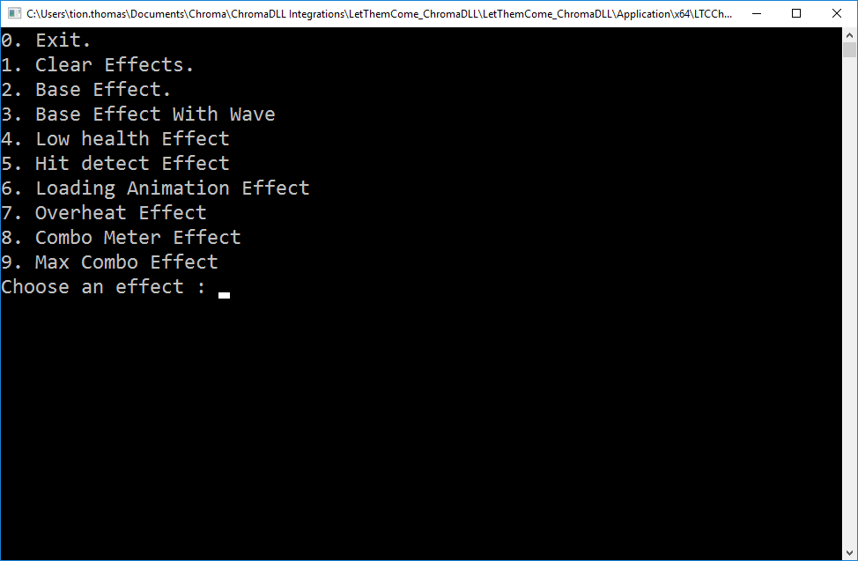

The LetThemComeChromaApp provides a simple command line interface to allow the user to specify a Chroma effect. The included effects are as follows:

- Base Effect - the base effect is the color highlighting of the common active keys on the keyboard including the W, A, S, D (movement keys), Left Shift, and Left CTRL keys to the ACTIVEKEYCOLOR. All remaining nonactive keyboard keys as well as the LEDs on the mouse, mousepad, and headset will turn the BASECOLOR
- Base Effect With Wave - this effect includes the base effect but adds a wave colored the WAVECOLOR that ripples from leftmost to rightmost columns and then again from rightmost to leftmost columns. Once the ripple is complete, the active keys will remain with all nonactive keys on the keyboard are unlit. The LEDs on the mouse, mousepad, and headset will also display the BASECOLOR
- Low Health - the low health effect is a LOWHEALTHCOLOR breathing effect of all nonactive keys on the keyboard along with all of the LEDs on the mouse, mousepad, and headset
- Hit Detect- the hit detect effect is a quick 3 flashes of the HITDETECTCOLOR on all nonactive keys on the keyboard along with all of the LEDs on the mouse, mousepad, and headset
- Loading Animation - the loading animation effect is unique in that it utilizes all of the Chroma devices in a serial fashion as opposed to displaying the effect in parallel. The effect begins with a LOADINGCOLOR wave highlight that slowly moves from left to right across the keyboard. Once the rightmost part of the keyboard is reached, the highlight then moves across to the Chroma enabled mouse one LED at a time. Next, the effect moves to the Chroma enabled mousepad one LED at a time and then to the Chroma enabled headset. Finally, the effect completes on any connected chroma link devices one LED at a time. Once complete, all devices are reset back to the base effect colors
- Overheat – the weapon overheat effect is a breathing effect similar to the Low Health Effect but colored OVERHEATCOLOR
- Combo Meter – the combo meter effect is a sequential highlighting of the F1-F12 keys one at a time to COMBOMETERCOLOR simulating the increasing values of the in game combo meter
- Max Combo – the max combo effect is a spectrum cycling of all the primary rainbow colors across all connected chroma devices to alert the user that the maximum combo level has been reached.

Note that you can alter the timings and colors of each effect to your liking when integrating into the game.

How to Hook the DLL from Your Application
The provided LetThemComeChromaAPP provides a minimal example of how to hook the DLL from an application. Here are key steps needed to trigger the event of the ChromaDLL:

#include "YourPath\LetThemComeChromaDLL.h" | You'll need to include the path to the ChromaDLL file
LoadLibrary(_T("LetThemComeChromaDLL.dll")); | Load the Chroma.dll file into your program
GetProcAddress(hModule, "TriggerEvent") | Retrieve the address of the exported TriggerEvent function defined in the ChromaDLL code
TriggerEvent(EVENT_NAME, NULL) | Call the Trigger Event function with the Event_Name defined in the ChromaDLL

List of Defined Events
In order to call the TriggerEvent function, the sample app must pass the specified event names as defined in the ChromaDLL. For Let Them Come, the following events are defined:
EVENT_CLEAR
EVENT_BASE
EVENT_BASEWAVE
EVENT_LOW_HEALTH_ACTIVE
EVENT_HIT_DETECT
EVENT_LOADING_ANIMATION
EVENT_OVERHEAT
EVENT_COMBO_METER
EVENT MAX_COMBO

Additional Contacts
Please contact the developer relations team with any additional requests or questions:
- Tion Thomas (Engineer): tion.thomas@razerzone.com
- Tim Graupmann (Engineer): tim.graupmann@razerzone.com
- Vik Long (Director): vik.long@razerzone.com
- Mark Tay(Manager): mark.tay@razerzone.com

